Git remote show origin
C:\AReact\thewill>git remote show heroku
Git status
https://fierce-beyond-88684.herokuapp.com/tlr

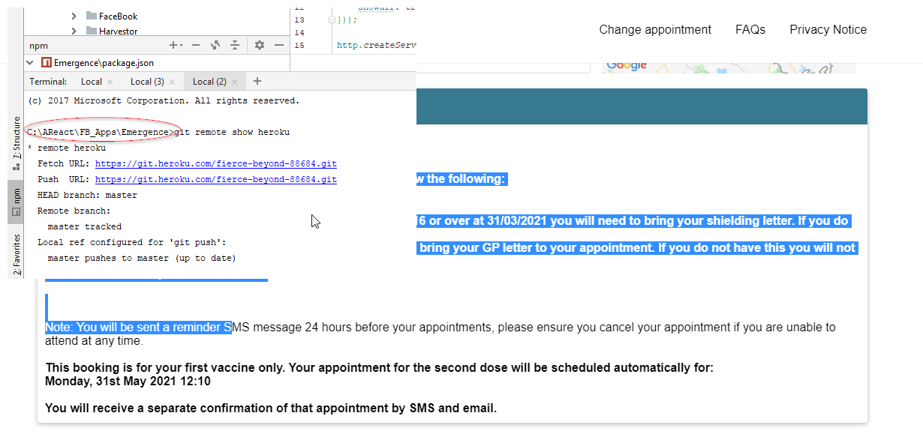

TheWill
